**Installing Git:**

**Step 1:**

**Download GitVisit the official Git website:🔗 https://git-scm.com/downloadsClick "Download for Windows" (it will automatically detect your system type: 32-bit or 64-bit).**

**Step2: Install Git using commands**

**Step 3: Verify Installation**

**After installation, open Command Prompt (cmd) or Git Bash and type:**

**git --version**

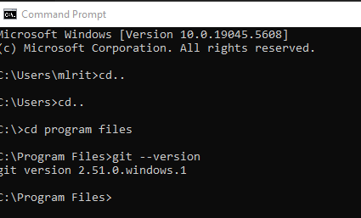

**Step 4: Configure git after Installation:**

**git config --global user.name "Your Name“**

**git config --global user.email your-email@example.com**



**Verify the configuration:**

git config --list

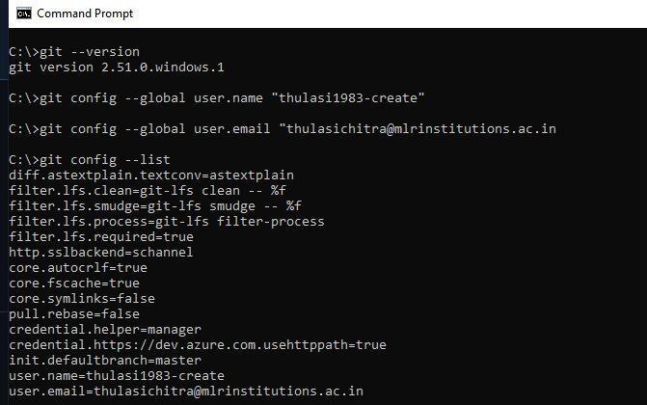

**First Git Project (Testing Git)**

**Create a new Git repository:**

mkdir my-project

cd my-project

git init

echo "Hello Git" > README.md

git add README.md

git commit -m "First commit"

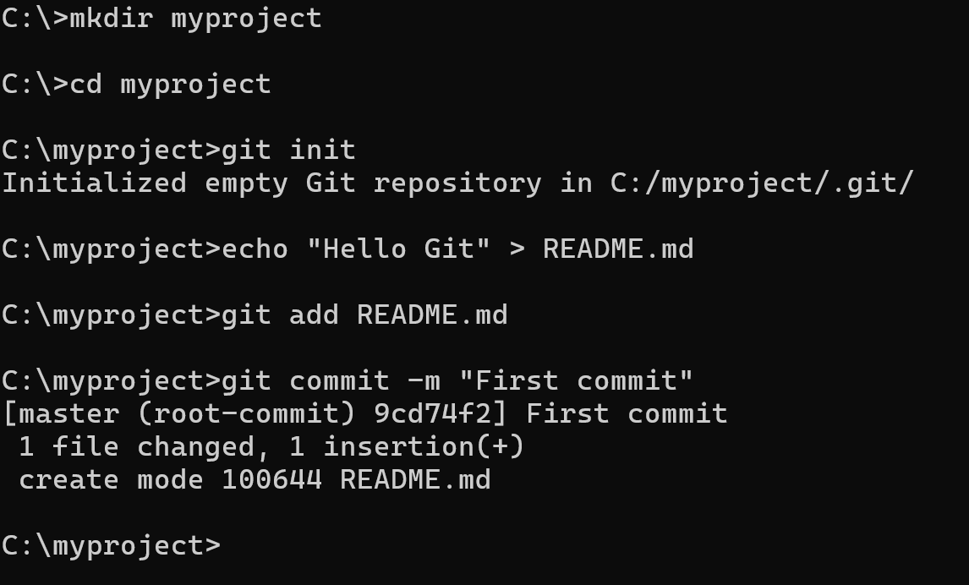

**GITHUB:**

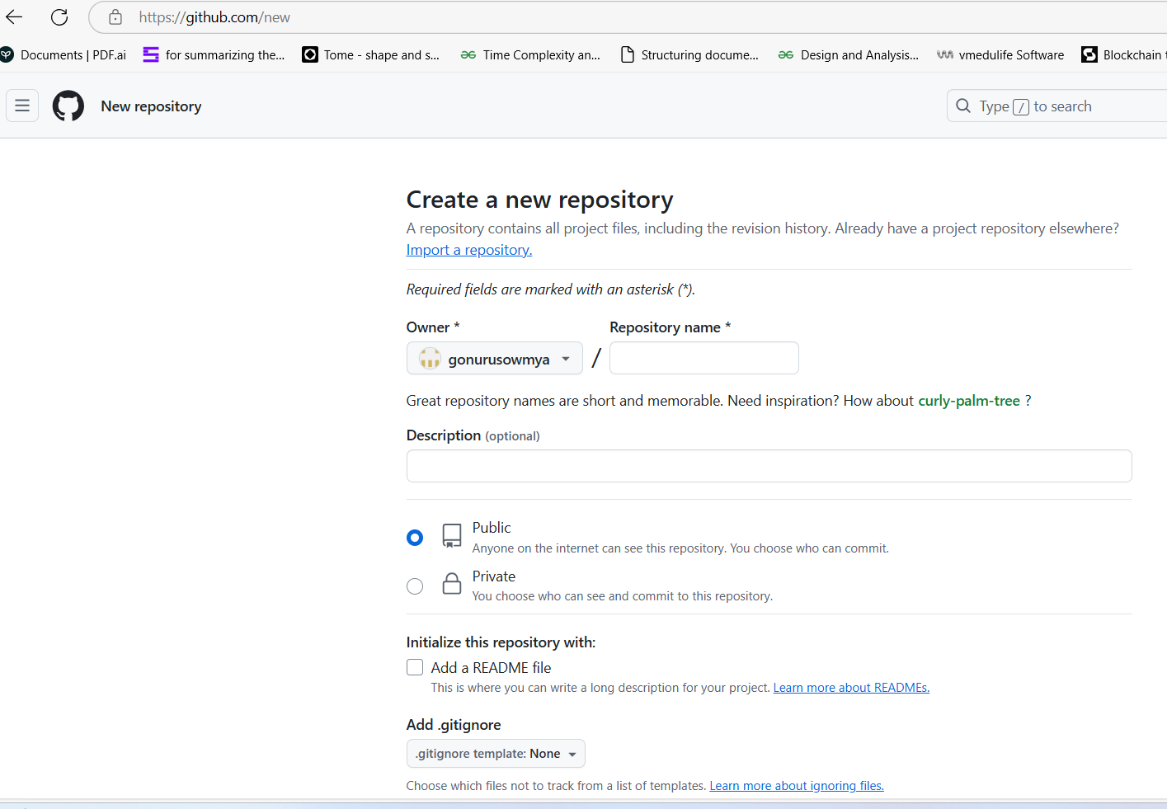

Link Your Local Repository to GitHub

Run the following commands in your terminal or command prompt:

git remote add origin https://github.com/your-username/my-project.git

**To verify the remote URL:**

**git remote -v**

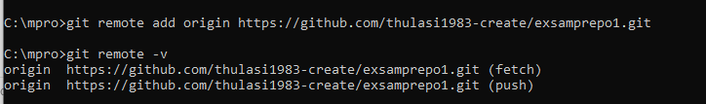

Push Your Code to GitHub:

Before pushing, ensure you have committed your changes:

**git commit -m "Initial commit“**

The "Initial Commit" refers to the first commit in a Git repository. It is the first saved version of your project when you start tracking files using Git.

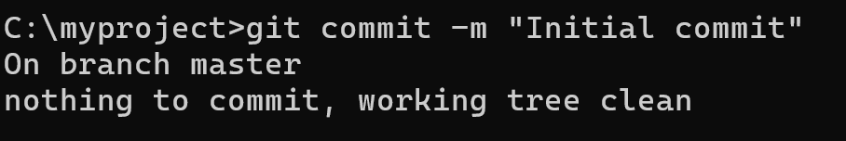

**Now, push the repository:**

**git branch -M main # Rename branch to main (if not already)**

**This command renames the current branch to main.**

**By default, Git used to name the first branch master, but now the standard default branch name is main.**

**This command ensures your repository follows modern conventions.**

**If your branch was already named main, this command does nothing**



**git push -u origin main**

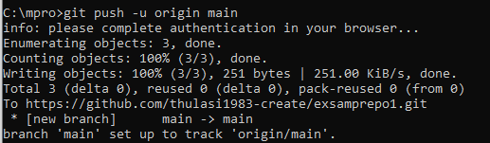

GITHUB TO GIT -Files to be moved

